**WS32 - SOFTWARE PRINCIPLES GROUPS**

**DATE: 03th february 2021**

**TEAM 7:**

Alan Andrade

Katherin Bravo

Darling Cruz

Jhon Guitarra

Alejandro de la Cruz

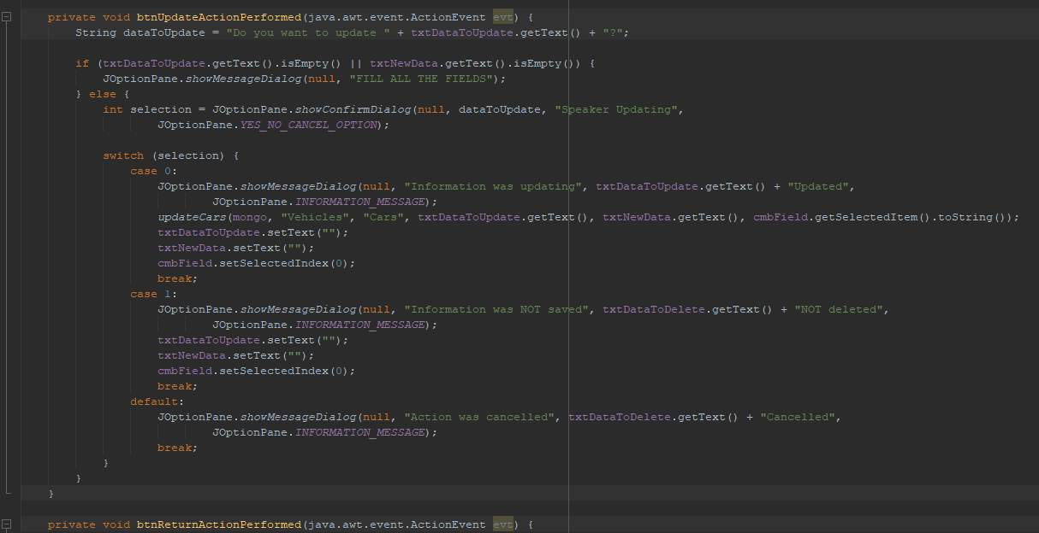

the button contains code

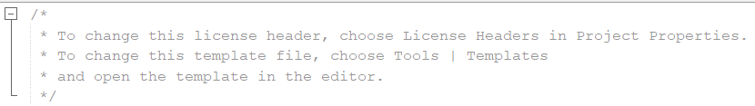

* The connection to the database is made by 2 classes when it should only have one

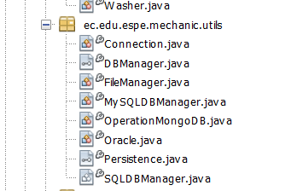

* Comments that are not necessary

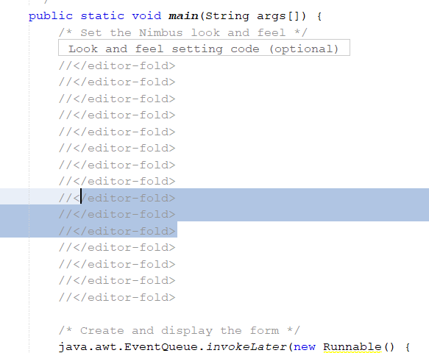

We must take into account the programming of the packages and know where each one is programmed.

The "getters" and "setters" must be programmed in the "model" package, not in the "controller" package, that's a big mistake.

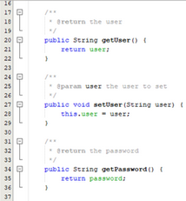

We must take into account the use of lowercase letters for the variables, since if we use uppercase letters we make a mistake.



*Open/Closed*

The names of the methods and variables are very general and are not specific.

